౨ৎ ˖⊹🦢࣪Team SWAN⊹₊ ⋆୨ৎ
The Women of SWAN - Exploring Diversity in the Menopause Journey
Team Members: Esha Choudhary, Kristen Donahue, Khushi Raj Mittal, Rabab Fatma, Mickey Lin, Mengting Tu

Project Vision: Menopause marks a major transition in life, deeply impacting physical, emotional, and social health. Yet most studies and tools overlook its diversity across women. Our goal is to create an interactive storytelling visualization which aims to communicate health disparities by revealing how demographic factors (race, geography, socioeconomic factors) influence health experiences beyond the purely biological process, while keeping the story engaging and accessible for the general public.

1. Data Walkthrough/Overview

a) Dataset: Study of Women’s Health Across the Nation (SWAN): longitudinal study (1996–2008).
- Baseline: ICPSR 28762 (1996–1997) - It captures racial/ethnic diversity and geographic variation, making it ideal for examining health disparities during a critical life transition that affects all women, yet impacts them unequally: https://www.icpsr.umich.edu/web/NACDA/studies/28762
- Midpoint: ICPSR 30501 (2006–2008): https://www.icpsr.umich.edu/web/NACDA/studies/30501
- Endpoint: ICPSR 32961 (2001–2003): https://www.icpsr.umich.edu/web/NACDA/studies/32961

Participants: Participants: 3,302 midlife women (ages ~40-55), chosen from 7 U.S. study sites. Each participant had a persistent SWANID that links her records across waves.741 variables spanning physical health, mental health, reproductive history, lifestyle, medications, and biomarkers

b) Key Attributes: The SWAN Baseline dataset contains comprehensive information on midlife women aged 40–55 years, capturing demographic, biological, lifestyle, and psychosocial factors related to the menopausal transition.
Key variables include:
- SWANID — a categorical variable representing each participant’s unique ID, allowing for tracking across study waves.
- Age — quantitative (in years at baseline), capturing participants’ ages between 40 and 55.
- Race/Ethnicity — categorical, including groups such as White, African American, Hispanic, and Chinese; useful for analyzing cultural and biological differences.
- Menopausal Status at Baseline — categorical (pre-, peri-, post-menopause), central to understanding changes in symptoms and well-being across menopausal stages.
- Age at Menarche — quantitative, providing biological context for reproductive lifespan.
- Smoking Behavior — includes cigarettes smoked per day and smoking status (categorical), reflecting lifestyle factors influencing health outcomes.
- Alcohol Consumption — quantitative, measuring frequency or amount of alcohol use.
- Physical Activity Level — categorical, indicating activity intensity or frequency, important for assessing lifestyle effects on health.
- Body Mass Index (BMI) — quantitative, representing physical health and weight status.
- Emotional Well-being and Daily Functioning Measures — categorical or ordinal variables including items like “Accomplished less” and “Worked less carefully,” reflecting psychological and functional health.
- Physical Symptoms and Medical Conditions — categorical indicators such as abdominal pain or cramps, back or joint pain, anxiety before periods, and arthritis, offering insights into physical health during the menopausal transition.
Together, these attributes allow for an integrated exploration of how lifestyle factors, emotional health, and physical symptoms differ across menopausal stages and racial or ethnic groups.
c) Data Exploration & Mapping Exploration:
We conducted an exploratory analysis of the SWAN baseline dataset to identify variables and relationships to incorporate into our visualization design ideas.
- Demographic Context: Age, Race, Site Counts
  - To establish the foundational context of the SWAN study, we examined participant distribution by race and geographic site
  - Visualizations: Interactive U.S. Map with the location of the sites and Stacked Bar Charts of the race distribution per site
  - The map enables users to connect health data to specific regions, while the stacked bar chart highlights racial and ethnic variation across the sites.
- Key Symptom Prevalence: Hot Flashes, Sleep Problems, Joint Pain
  - We will compare the top symptoms across racial groups to reveal disparities in menopausal experiences
  - Visualization: Horizontal Bar Charts for direct comparison and possibly Pictogram Charts using heart icons to humanize the data
  - The bar chart would be good for visualizing categorical comparisons and make disparities instantly recognizable, like 80% black women vs 35% of Japanese women reporting hot flashes.

Side-by-side comparisons between menopause experiences by race:
Hot Flashes:
Black ████████ 80%
Hispanic ██████ 70%
White █████ 55%
Chinese ████ 45%
Japanese ███ 35%

  - Pictogram charts complement this by framing data through a more empathetic, story-driven lens
- Cluster Analysis: Distinct Menopausal Journey
  - 100-Women Pictogram Grids showing cluster proportions, Profile Cards detailing characteristics per cluster, and Bar Charts of cluster membership by race.
  - The Pictogram grid shows how many women fall into each experience type. Profile cards and star plots provide depth, while bar charts highlight racial disparities in cluster composition. Together, these visuals bridge empathy and analysis, encouraging users to see themselves within the data.
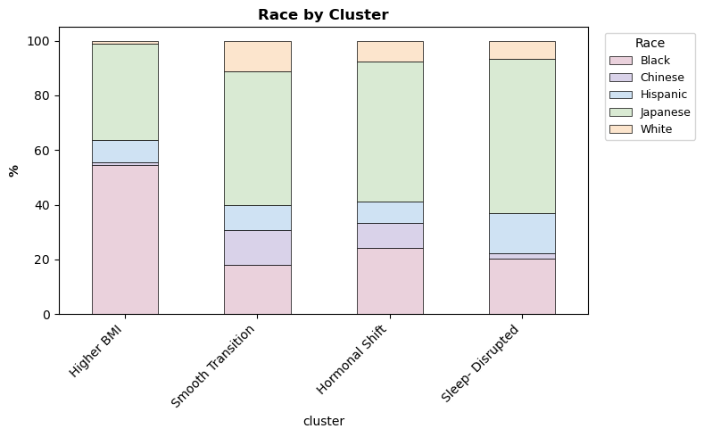
K-means clustering (k = 4) revealed four distinct menopause experience types, each defined by unique health, hormonal, and demographic profiles.
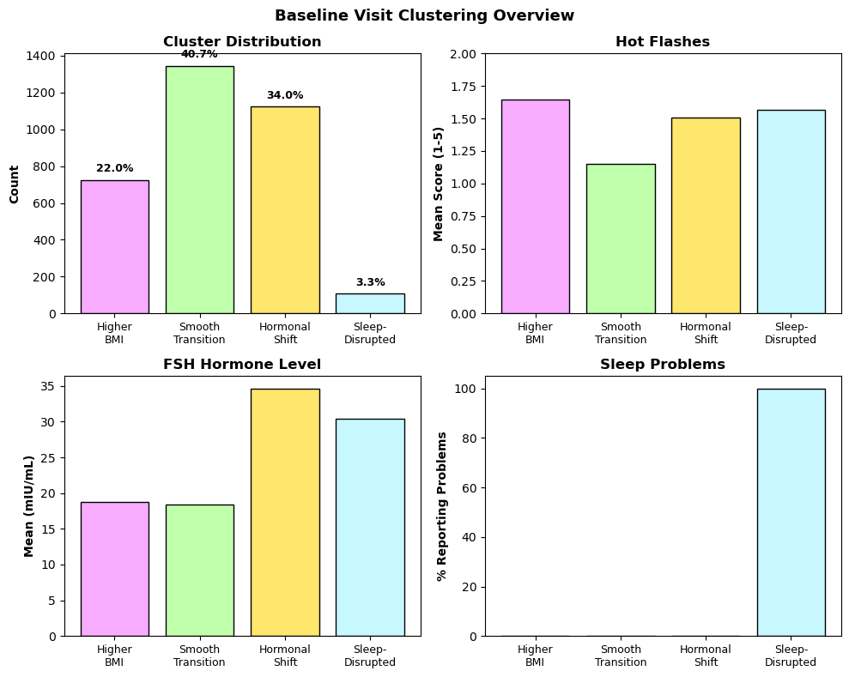

Cluster Name | Core Characteristics | Demographic Insight
1.Low Baseline (41% of sample) | Low baseline symptoms, lowest depression, and healthy BMI. | This group, despite having the healthiest lifestyle, exhibited the lowest bone density (0.925). They also experienced the largest increase in hot flashes over 10 years. 49.1% of this cluster were Japanese women.
2.Early Shift (34% of sample) | Highest baseline FSH (33.5), indicating an early transition. | Moderately healthy lifestyle, mid-range bone density.
3.Higher BMI (22% of sample) | High BMI (38), but fewer reported symptoms. | This group had the highest blood pressure (132 mmHg) and the best bone density (1.079). Notably, 54.5% of this cluster were Black women (compared to 27% in the overall sample).
4.Sleep-Disrupted (3% of sample) | 100% sleep problems, high depression. | This group saw the largest BMI increase over time (from 27.3 to 29.4).
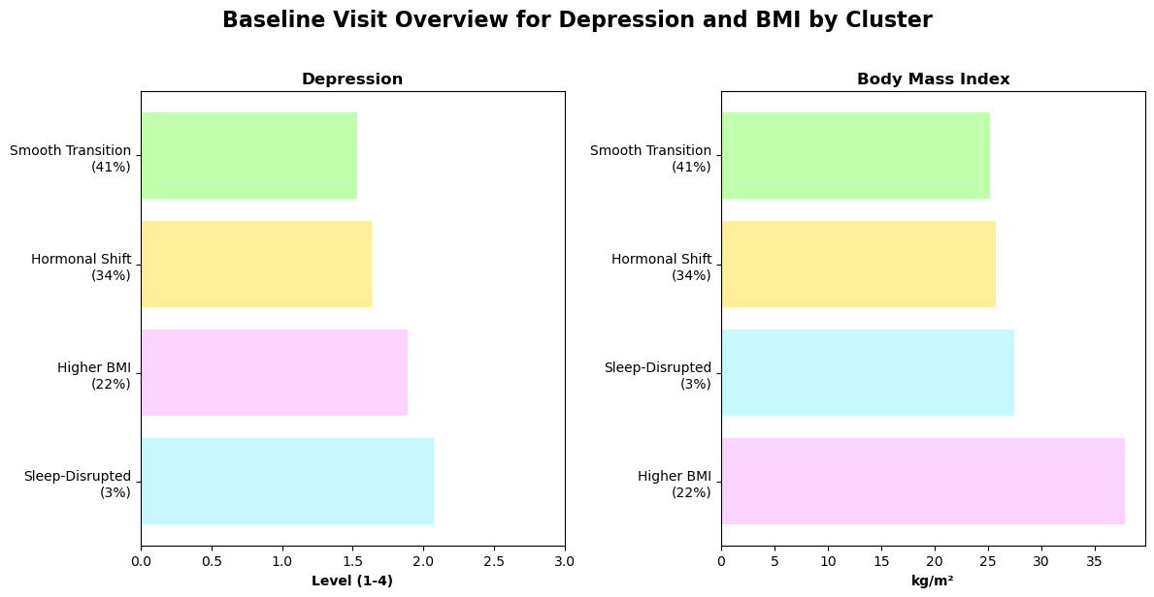

- Additional Pattern Exploration: We then identified 48 granular symptom labels to find more hidden and detailed patterns beyond our clustering analysis
  - Top Symptom Prevalence: Highest frequency symptoms for all participants at the baseline visit
    - Top 20 symptoms across all women for baseline visit only:
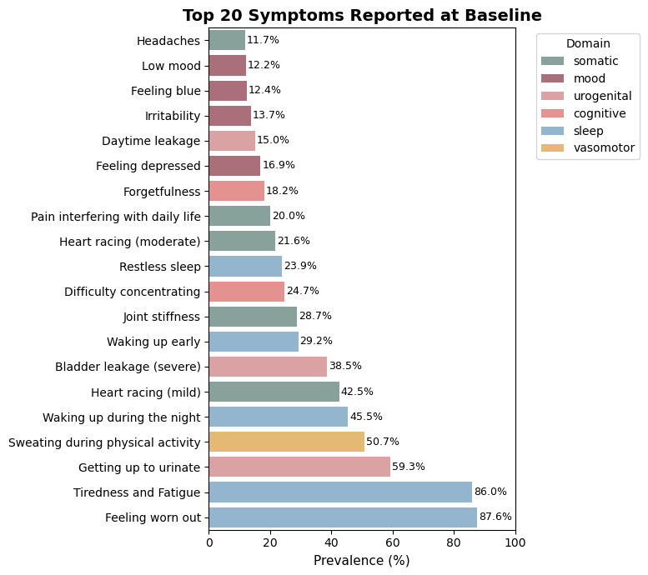
    - Top 20 symptoms across all women for all visit data combined:
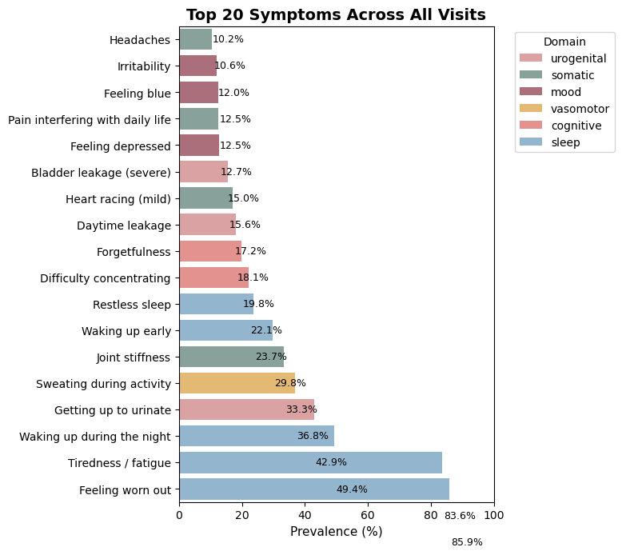
  - Symptom Trajectories: Tracking symptoms across all 3 visits (10 years) to identify patterns & generate predictions
    - Some symptoms improved (urinary leakage)
    - Some symptoms didn’t change (fatigue)
    - Some symptoms worsened (hot flashes and vaginal dryness)
  - Domain-Based Grouping: Created 6 symptom groups to organize all 48 symptoms on a higher level, complementing the clustering analysis.
    - All symptom groups include: urogenital, sleep, cognitive, vasomotor, mood, and somatic symptoms
- Life Style Habits: Smoking, Exercise, BMI, Alcohol Use
  - Lifestyle behaviors can influence women’s health trajectories too
  - Visualization: Icon-Based Infographics (🏃‍♀️ exercise, 🚬 smoking, 🍷 alcohol, 🥗 diet) and Small-Multiple “Menopause Flower” Star Plot comparing lifestyle-health dimensions
  - The icon-based visuals will simplify complex behavioral data and appeal to users to interact with the data by inputting their own habits later. The star plots allow multidimensional comparisons at a glance
- Longitudinal Trends (10 - Year Outcomes) Explorations:
  - Hormone Trajectories: FSH levels, regardless of starting point, tend to converge to approximately 117 mIU/mL by Visit 10, highlighting a shared biological endpoint despite different trajectories.
  - Physical Activity: All groups showed a slight decrease in physical activity over the 10 years.
  - BMI vs. Bone Density: The data suggests a correlation where a higher BMI indicates better bones (as seen in the Higher BMI cluster), while a lower BMI doesn't guarantee healthy bones (as seen in the Low Baseline cluster).

Data Mappings - We will integrate this data using consistent mappings: Race and Cluster Type are mapped to color. Design ideas include a Geographical Map (site size by sample size), Horizontal Bar Charts showing top symptom prevalence, and a Scatter Plot highlighting the positive correlation between BMI and bone density. Longitudinal changes will be visualized using Line Charts showing trajectories (e.g., FSH, hot flashes) animated on scroll.

Data Attribute | Type | Visual Encoding | Used In
Age | Quantitative | Position & size | Demographics
Symptom Prevalence | Quantitative | Bar chart lengths & icon counts | Symptom charts
Cluster Type | Categorical | Color & shape | Cluster views
Race | Categorical | 5-color palette | All views
Symptom Domain | Categorical | 6-color palette | Domain profiles
Visit Number | Ordinal | X-axis position | Trajectories

2. Target Users

- General Public or anyone interested in learning more about women’s health and menopause (especially women aged 35-60).
- Users will accomplish: Users will use the visualization to understand how women’s midlife health experiences differ during the menopause transition. It might be helpful for health researchers and policy makers to explore demographic disparities between women’s experiences during menopause through intuitive visualizations. It might also help educators and advocates to communicate menopause diversity and promote awareness.
- It will help users understand what symptoms are most common, who is most affected, and where gaps in care may exist.
- It will also personalize the story, allowing users to consider where they or someone they might know might lie.The high-level purpose is presentation or storytelling.
- User Domain Knowledge: Users are only expected to know a few basic health-related terms such as Depression, BMI, and bone density. Specialized terms like FSH (Follicle-Stimulating Hormone) may need to be defined within the visualization

User Questions
- Who are the women studied in SWAN (diversity, age, geography)?
- How do symptoms evolve through menopause?
- What lifestyle factors influence outcomes?
- How do experiences differ among women?
- How changes happen over time?
- Does race or geography matter?
- Where do I “fit” in these experiences?

3. Design thinking so far

The visualization will accomplish the storytelling purpose by communicating health disparities experienced during the menopause transition. It moves the reader from a general overview to specific, revealed patterns, following Shneiderman's mantra (overview → filter → details)

We’ll use Observable Framework for scrollytelling, combining empathy (pictograms), insight (clusters), and interactivity (filters, sliders, hover details).

The user will move from one story point to the next by scroll-triggered animations. The user will also be able to hover over tooltips on data points and explore parameters to see the effect of different factors. Interactions will follow principles like select, filter, reconfigure, and details (brushing & linking)

The narrative flow guides the reader through demographic context, symptom commonality, the reveal of heterogeneous experiences (clusters), longitudinal changes, and specific disparities.

Story Point | Focus / Goal | Visualization Method
1. Who Are These Women? | Establish scope, diversity, site distribution and give context. | Interactive filled US map with 7 SWAN sites, dots sized by sample size; bar charts showing age, race, and city/site distribution.  Explore and hover over sites to get further information.
2. The Shared Experience (Symptoms/Progression) | Show the general progression of menopause and top symptoms across all women across visits (Baseline, Visit 5, Visit 10). | Horizontal bar chart showing symptom prevalence.  Bar chart of top 10 symptoms (e.g., hot flashes, sleep disturbance, mood changes).
3.“Not All Journeys Are the Same”  Pattern Reveal (Clusters) | Introduce the core insight: the four distinct menopause types derived from K-means clustering. | Icon array (100 women) colored by the four cluster types; rotatable profile cards for each cluster showing specific stats.  We can use scroll-triggers which can reveal profile cards.  Radar/flower charts for 6 health dimensions.
4. How Their Bodies Change | Show how key health indicators (hormones, symptoms) change over the 10-year period for each cluster. We can also change during different transition phases. | Line charts showing trajectories (FSH, hot flashes, depression) by cluster, animated on scroll. Small multiple line charts for BMI and bone density.
5. Experience Not the Same “Why It Matters: Diversity and Disparities” | Tie biological and social factors together..Highlight how demographic factors like race influence cluster membership and symptom prevalence. | Side-by-side bar charts showing symptom prevalence by race; stacked bars showing cluster membership by race.  Highlight key disparities.
6. Summary and Personal Interaction | Recap key findings ("There’s no ‘normal’ menopause). Wrap up with awareness and empathy.Also allow personalization. | Summary of the journey and insights gained.  User Interaction Chart where the user can slide/input their own data to see correlations

4. Design Ideas and Example Views

a) Meet the Women: This section establishes the context and diversity of the SWAN study cohort (3,302 midlife women from 7 U.S. sites).

- Geographical Map Viz (Idea 1)

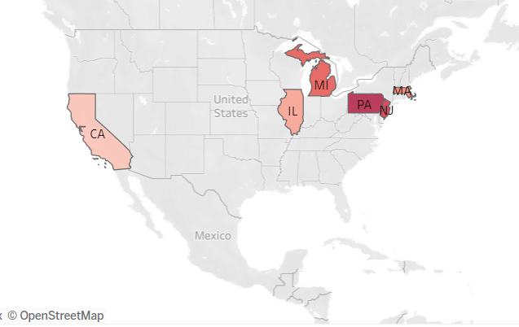

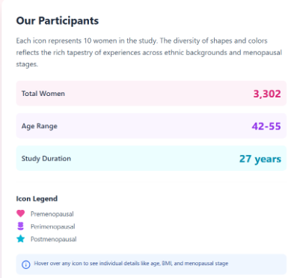
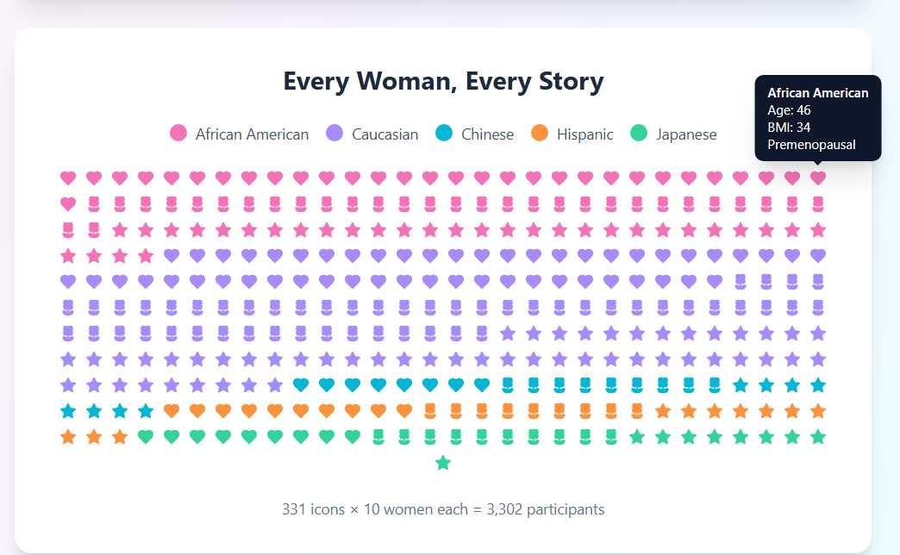
Pictogram Grid (Idea 2)
Interaction: Brushing over a site icon would show an info card displaying the demographics specific to that site. This fulfills the task of answering "Who are the participants (where from)?" etc.

b) The shared Experience

- Overall Symptoms (Idea 1)

Top 10 symptoms across ALL women
Hot flashes ████████████████░░ 67%
Sleep disturbances ██████████████░░░░ 54%
Joint/back pain █████████████░░░░░ 52%
Mood changes ███████████░░░░░░░ 48%
Anxiety ██████████░░░░░░░░ 43%
[etc.]

c) “Not All Journeys Are the Same” Pattern Reveal (Clusters) : This is the core storytelling moment, introducing the discovery that menopause is not uniform but follows distinct patterns

Idea 1

Symptom Prevalence by Race - The Disparity Revealed
White Black Hispanic Chinese Japanese
Hot Flashes ███ ████ ██ █ ██
Night Sweats ██ ████ ███ ██ █
Mood Changes ████ ███ ████ ███ ████
Sleep Problems ███ ████ ███ ██ ███
Joint Pain ██ ███ ██ █ ██
[... more symptoms]
Legend: █ = 10% prevalence
Interaction - Hover over the bars and get more information.

Idea 2

Idea 3: This visualization, “Symptom Patterns Across Groups,” uses heart icons to illustrate how the prevalence of hot flashes and sleep issues changes over time (Visits 0, 5, and 10) among five racial/ethnic groups in the SWAN study. Each color represents a group, and the number of filled hearts indicates how many women reported each symptom. The design makes trends easy to compare, showing, for instance, that African American and Hispanic women experienced higher symptom rates, while Chinese and Japanese women reported fewer while the soft, pictogram style communicates these patterns in a warm, human-centered way.

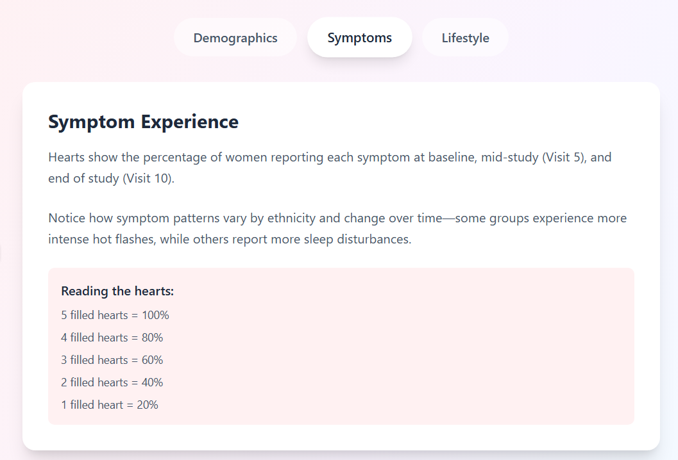
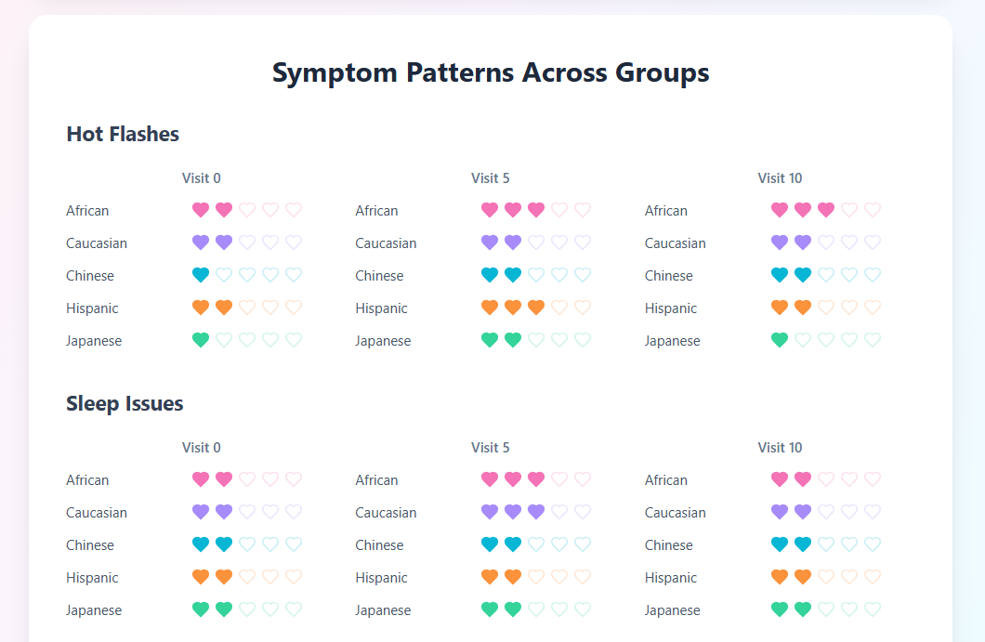

d) Lifestyle and Care Lens
Idea 1
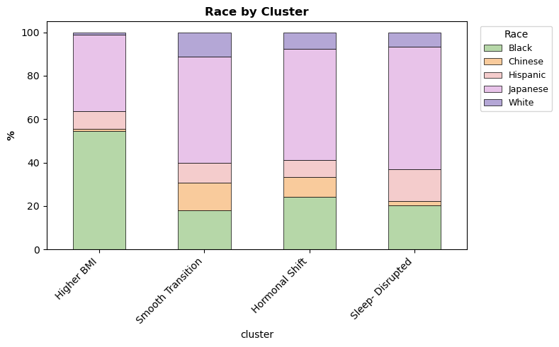
Idea 2 : Icon-based infographic
Small icons for exercise 🏃♀️ diet 🥗 smoking 🚬 alcohol 🍷.
Colored outlines show prevalence by demographic.
Hover reveals fun fact: “African American women: 35 % exercise > 3× week

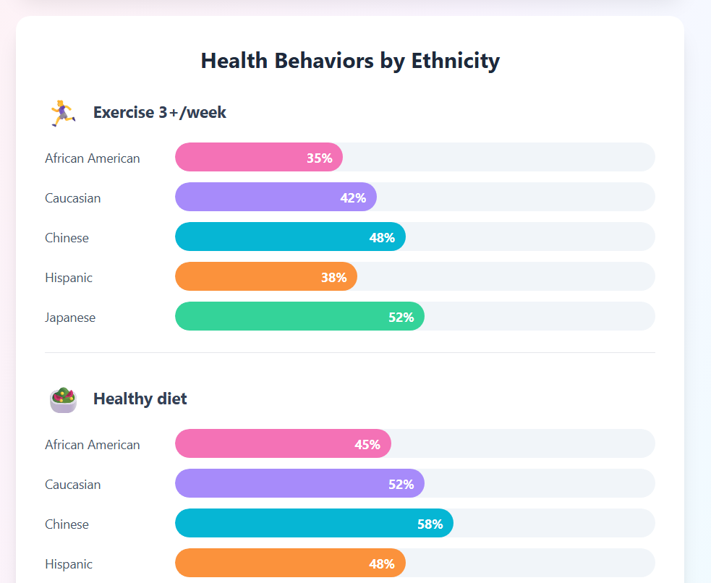
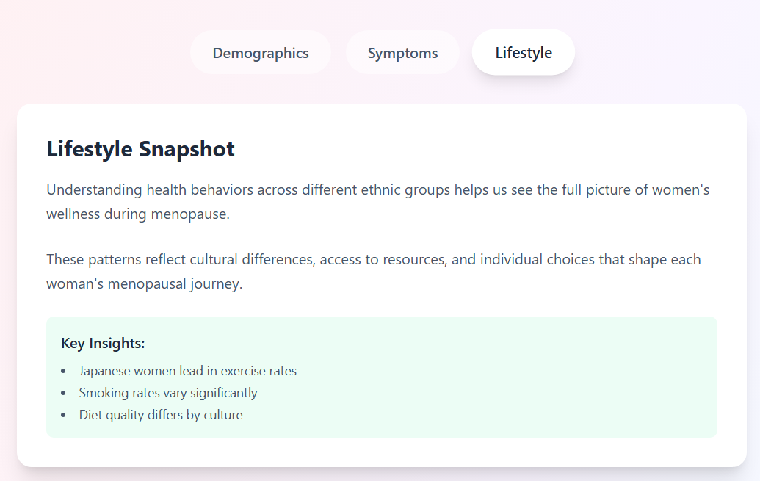

Demographic profiles (small-multiples flowers). Chart: Menopause Flower (radar/star plot) in small multiples, one card per demographic group. Axes/petals (6): Sleep 🌙, Mood 🧠, Hot Flashes 💓, Bone 🦴, Heart ❤️, Hormones 💧
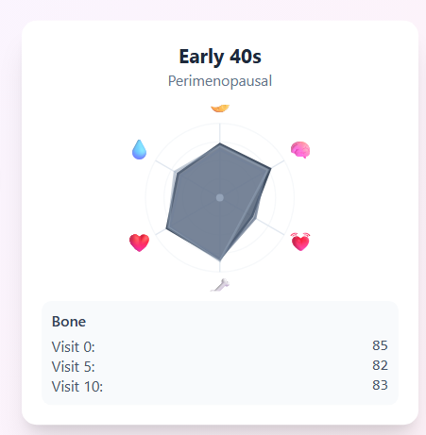
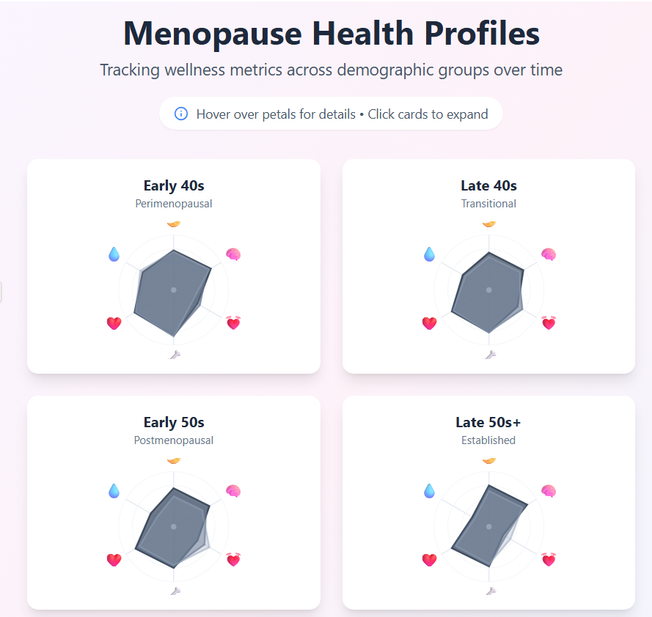
Temporal layering: 3 translucent rings = Visit 0 / 5 / 10 (baseline/mid/end). Why: quick, side-by-side profile comparison by group and over time. Interaction: hover highlights one petal with a tiny tooltip, click a card to expand.

